**Figure 2, panel A, short exposure (SE)**

Cropped area marked by red box.



30

10

5

1

Mix

CC

CCA

**Figure 2, panel A, long exposure (LE)**

Cropped area marked by red box.



30

10

5

1

Mix

CC

CCA

**Figure 2, panel B**

Cropped area marked by red box.



30

90

10

0

CCA

CC

Mix

**Figure 2, panel D**

Cropped area marked by red box.



Mix

CCA

CC

**Figure 2, panel E**

Cropped area marked by red box.



**Figure 2—figure supplement 1, panel B**

Cropped area marked by red box.



**Figure 2—figure supplement 3, panel A**

Cropped area marked by red box.



**Figure 2—figure supplement 3, panel B**

Cropped area marked by red box.



4x Adp, 20% DMSO

4x Adp

20% DMSO

No additive

Input

**Figure 2—figure supplement 3, panel C**

Cropped area marked by red box.



**Figure 2—figure supplement 4, panel A**

Cropped area marked by red box.



**Figure 2—figure supplement 4, panel B**

Cropped area marked by red box.



**Figure 2—figure supplement 4, panel C**

Cropped area marked by red box. After cropping the image was horizontally flipped to place the ladder on the right side.



Input

NCMPL

l1Sp

**Figure 2—figure supplement 5, panel A, top**

Cropped area marked by red box.



**Figure 2—figure supplement 5, panel A, bottom**

Cropped area marked by red box.



**Figure 2—figure supplement 5, panel B**

Cropped area marked by red box. After cropping, the image was color inverted to black/white.

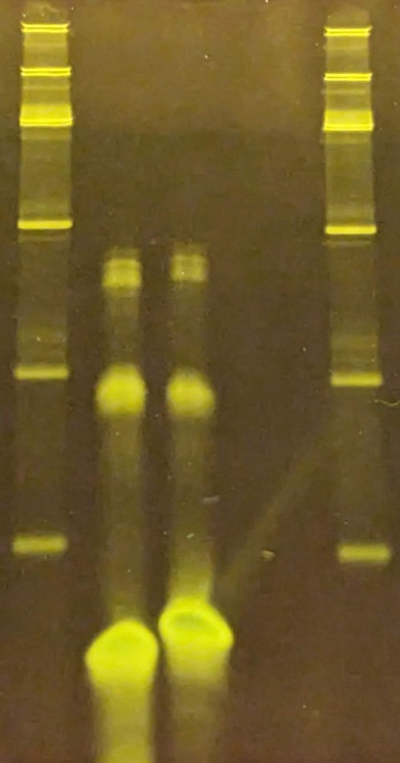

**Figure 2—figure supplement 6, panel A**

Cropped area marked by red box.



**Figure 2—figure supplement 10, panel A**

Cropped area marked by red box.



**Figure 2—figure supplement 10, panel B**

Cropped area marked by red box.



**Figure 5—figure supplement 3, panel A**

Cropped area marked by red box.



**Figure 6—figure supplement 1, panel A**

Cropped area marked by red box.

